Recognized pattern: Aple_variety1

The pattern has a form:

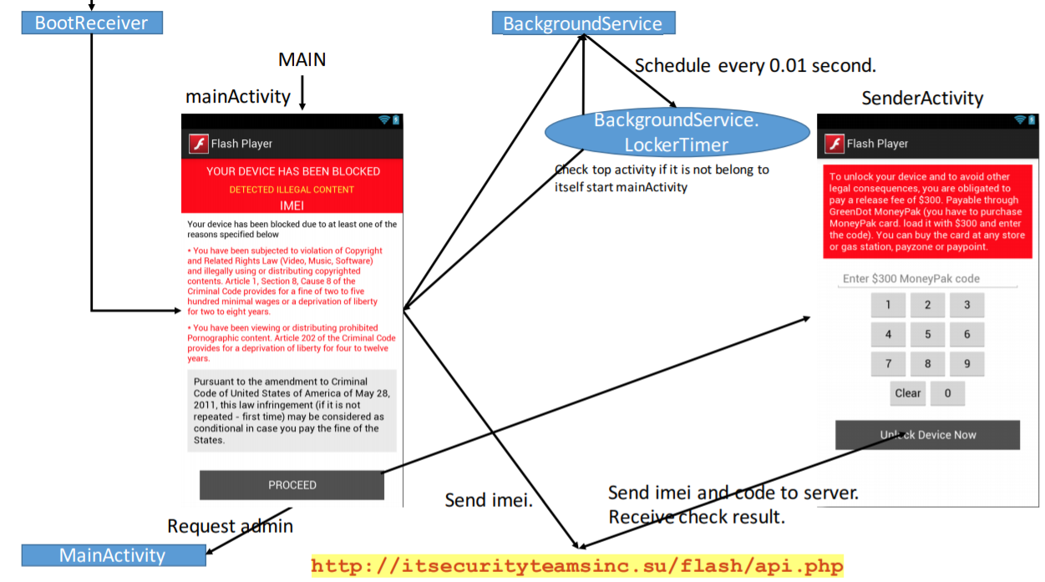

Name of Sample app: Flash Player

The name of this app: WorldScope

For functional modules:

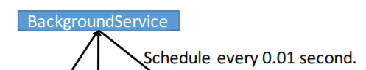

Corresponding to the key code in sample app:

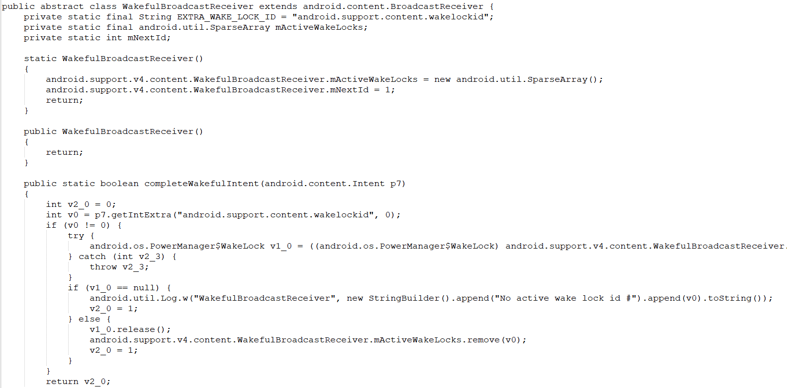

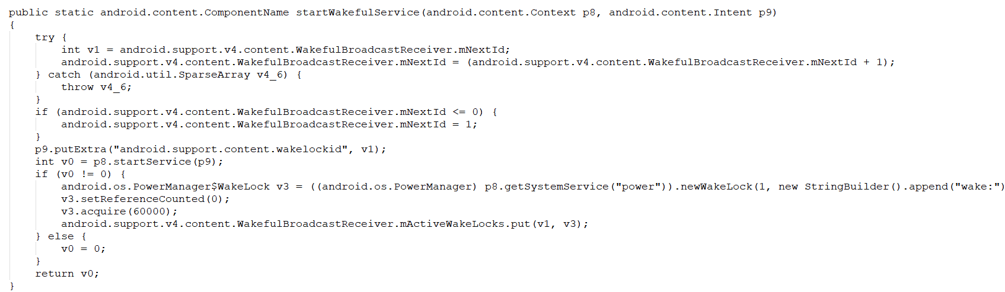

Corresponding to the key code in this app:

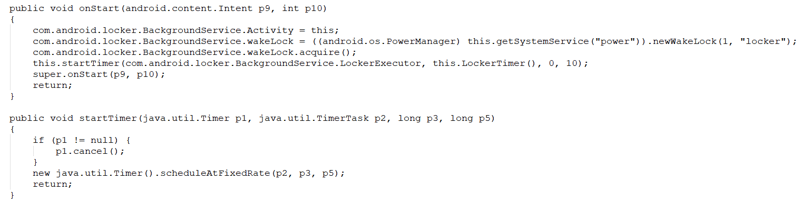

For functional modules:

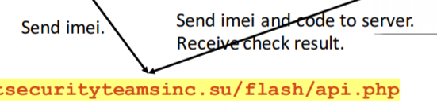

Corresponding to the key code in sample app:

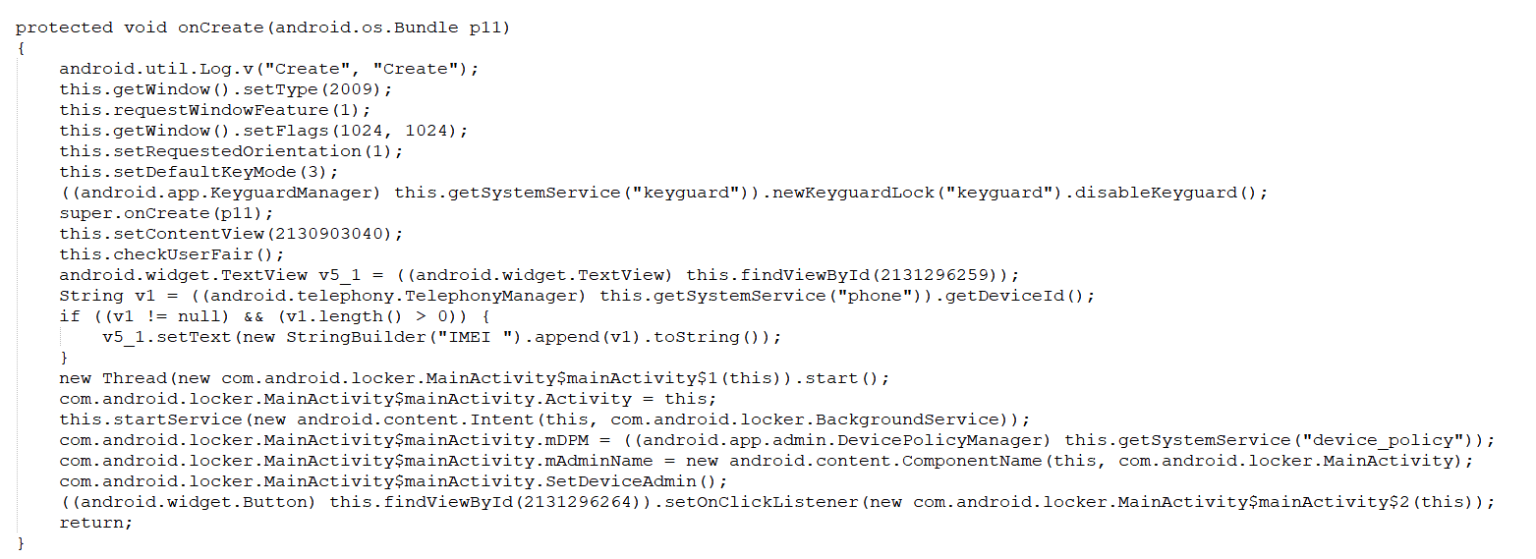

Corresponding to the key code in this app:

